**Inverse Matrix Program**

In this program I’ have used c++ language to make it. I’ll describe what I have done briefly.

**1 ) RecieveMatFromUesrInput() function**

Purpose of this function is to get input matrix from standard input.

This function was wrote in those previous lab, it’s look like this

So now we got a Matrix. Then we wait for process inverse in next function.

**2 ) InverseMatrix(Mat* m) function**

As you see below this function just calculate determinant which I have wrote in last lab.

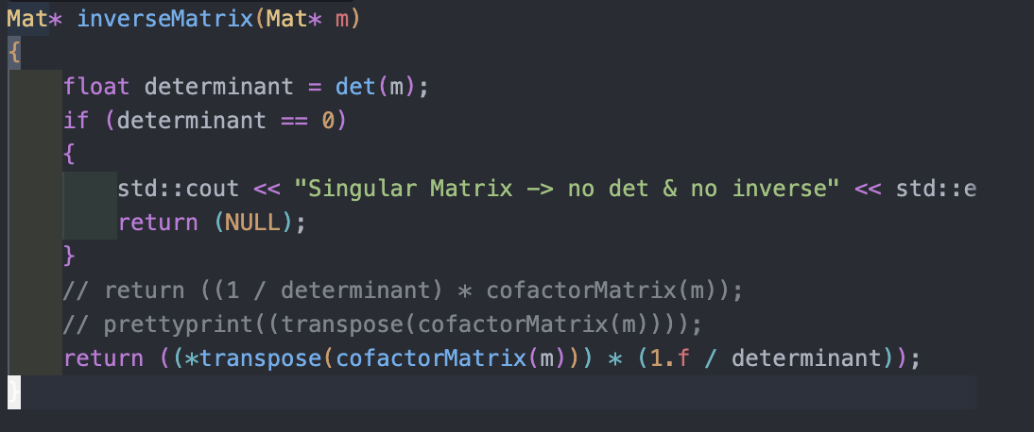

The core of result is

$$A^{-1}=\frac{1}{det}adj\left(A\right)$$

The only thing we need now is $adj$ so we just find by transpose function and $cofactorMatrix$ I will only show how this function work here.

This CofactorMatrix( ) Function return A Cofactor matrix of original matrix

By simply calculate minor matrices and apply sign to it.

The cofactor Matrix function iterate over all entries of matrix then we use sub function to get minor then apply minor by right sign yield the final result cofactor.

The getMinorMatrix( ) function receive original big matrix and minor matrix which prepared before. Then it will ignore the column and row that synchronize with exclude variables. The final result yield minor matrix back to a function.

As those functions work we’ll get cofactor matrix which step us to find inverse matrix that we wanted.

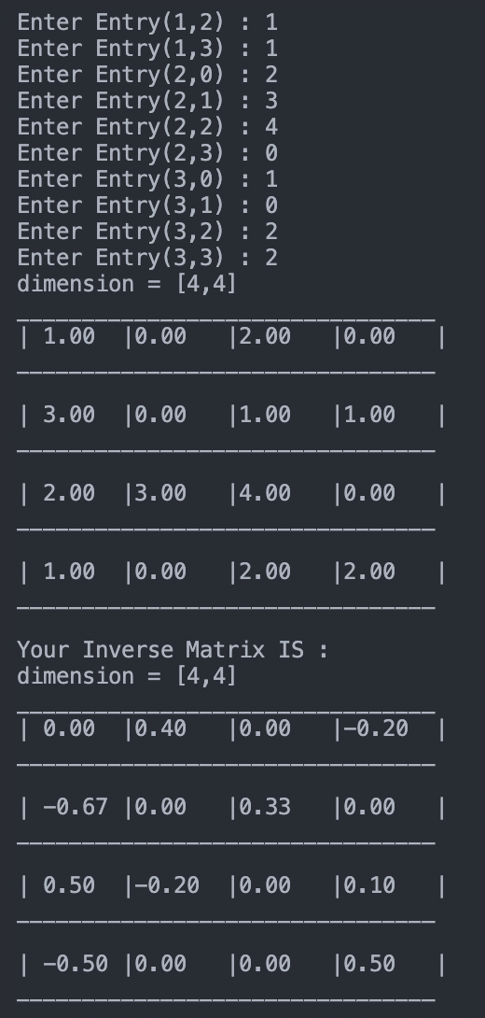

How to use this program